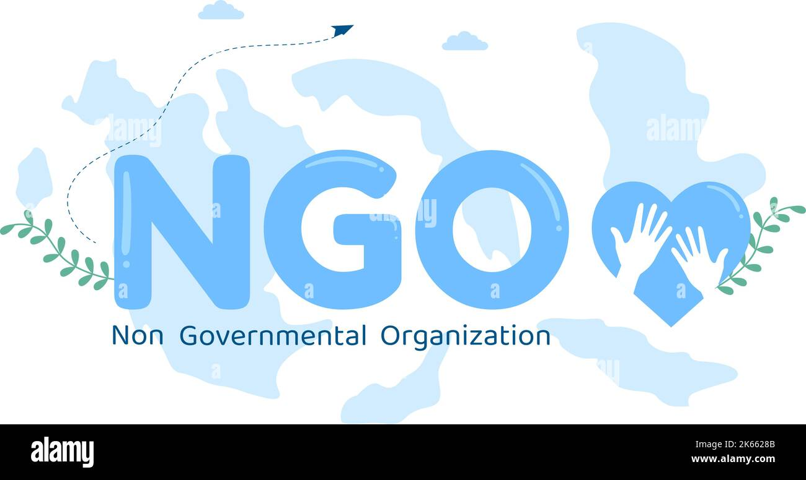NON-GOVERNMENT ORGANTSATION IN INDIAN:OPPORTUNITIES AND CHALLENGE

Literacy India

**Abstract**

**Non-Governmental Organisations, by virtue of being small in size, flexible, innovative and participatory, are widely considered to be more successful in reaching the poor, and in poverty alleviation. This paper, based on the review of existing studies and the author’s research experience with a large number of NGOs in India, aims at discussion on definition, types (Section 2), evolution (Section 3), advantages (Section 4) and weaknesses (Section 5) of NGOs. The discussion on evolution of NGOs shows that the perspectives of NGOs widened from charity and welfare to development, and to sustainable development and empowerment. This has been influenced by the policies of donor agencies and the Indian government. After discussing funding sources (Section 6), this paper argues that the NGOs need to play a dynamic role in the context of liberalisation policies, improved credibility and legitimacy for NGOs, etc. (Section 7). Further, this paper goes on to discuss a viable strategy for NGOs (Section 8).**

**Topic:** Abstract

Phases

Importance

Area of up gradation

Conclusion

The reference

* Introduction

Your generous donation to IVI will not only help stop ‘preventable’ blindness, particularly among children from underprivileged communities, but also help strengthen the eye care delivery infrastructure in India.

Uncorrected refractive error remains a major cause of avoidable vision impairment and the second most common cause of blindness in India. Visual impairment caused by this issue is preventable or treatable, usually through a simple pair of glasses.

Your contribution will help meet the challenge of reversing the rather grim eye care situation for our country, currently ranking among countries with the highest number of visually impaired population.

**You could also donate towards a range of other IVI initiatives in the following key areas:**

› Capacity building  
› Leadership initiatives  
› Optometry Education & Research  
› Creating awareness about eye care  
› Vision screening & provision of glasses

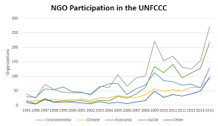

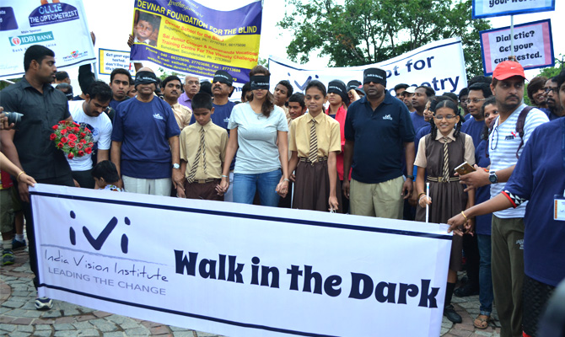

Walk in the Dark

Creating awareness about the importance of eye care and the role played by Optometrists in eradicating preventable blindness is an important component of IVE long term strategic plan.

Walk in the Dark is a one of its kind awareness t to creating awareness about the importance of eye care and the role played by Optometrists in eradiating preventable blindness. The Walk involves walking blindfolded while being guided by a visually challenged local students. Local dignitaries and people from all walks of life join the walk to create awareness.

You can either donate towards the cost of organizing the entire Walk or for separate components supporting participation of visually challenged children, ranging from Rs 25,000/- to Rs 1,00,000.

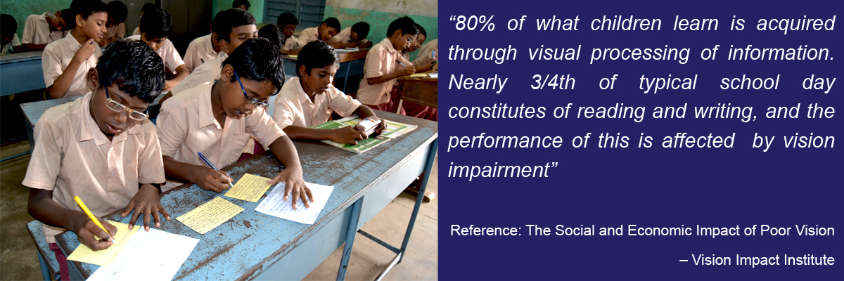

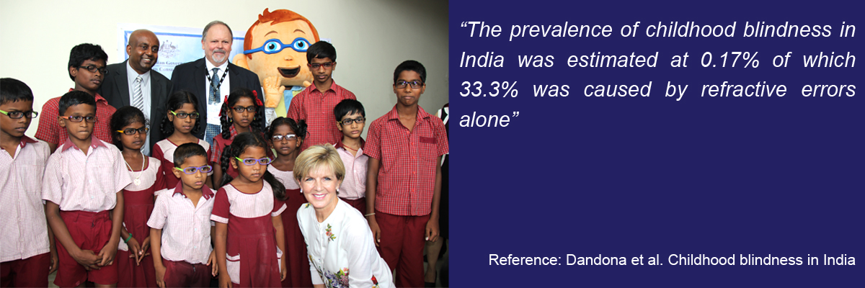

Eye See & I Learn

* **Phases**

Your donation of Rs 500 towards a pair of spectacles will provide someone the opportunity to continue to work to their full potential and earn a decent living!

Uncorrected refractive error remains a major cause of avoidable vision impairment and the second most common cause of blindness in India. Visual impairment caused due to uncorrected refractive error is preventable or treatable, usually through a simple pair of spectacles. The World Health Organization (WHO) estimates that approximately 3.93 crore, including 16 lakh children in India, are blind or visually impaired due to uncorrected refractive error.  Equally bothering is the fact that India loses approximately 126,500 crores in lost productivity due to uncorrected refractive error.

Lead the change with us to prevent avoidable blindness. Support Eye See & I Work.

All donations shall qualify for deductions u/s 80 G of the Income Tax Act 1961.

### **Methods**

A scoping review of the published literature was performed to identify the extent to which secondary analysis of NGO data has been used in health policy and systems research (HPSR). A tiered analytical approach provided a comprehensive overview and descriptive analyses of the studies that (1) used data produced or collected by or about NGOs; (2) performed secondary analysis of the NGO data (beyond the use of an NGO report as a supporting reference); and (3) analysed NGO-collected clinical data.

### **Results**

Of the 156 studies that performed secondary analysis of NGO-produced or collected data, 64% (*n* = 100) used NGO-produced reports (mostly to a limited extent, as a contextual reference or to critique NGO activities) and 8% (*n* = 13) analysed NGO-collected clinical data. Of these studies, 55% (*n* = 86) investigated service delivery research topics and 48% (*n* = 51) were undertaken in developing countries and 17% (*n* = 27) in both developing and developed countries. NGOs were authors or co-authors of 26% of the studies. NGO-collected clinical data enabled HPSR within marginalised groups (e.g. migrants, people in conflict-affected areas), albeit with some limitations such as inconsistent and missing data.

### **Conclusion**

We found evidence that NGO-collected and produced data are most commonly perceived as a source of supporting evidence for HPSR and not as primary source data. However, these data can facilitate research in under-researched marginalised groups and in contexts that are hard to reach by academics such as conflict-affected areas. NGO–academic collaboration could help address issues of NGO data quality to facilitate their more widespread use in research. The use of NGO data use could enable relevant and timely research in the areas of programme evaluation and health policy and advocacy to improve health and reduce health inequalities, especially in marginalised groups and developing countries.

* **Reference**

[NGO | Trust | India Vision Institute - India Vision Institute](https://www.indiavisioninstitute.org/donate-now)

### **[Non-Governmental Organisations (NGOs) in India](https://www.researchgate.net/publication/286786577_Non-Governmental_Organisations_NGOs_in_India_Opportunities_and_Challenges)**

[](https://www.researchgate.net/publication/286786577_Non-Governmental_Organisations_NGOs_in_India_Opportunities_and_Challenges)

[ResearchGate](https://www.researchgate.net/publication/286786577_Non-Governmental_Organisations_NGOs_in_India_Opportunities_and_Challenges)

[https://www.researchgate.net › publication › 28678657...](https://www.researchgate.net/publication/286786577_Non-Governmental_Organisations_NGOs_in_India_Opportunities_and_Challenges)

This **paper**, based on the review of existing **studies** and the author's **research** experience with a large number of **NGOs** in India, aims at discussion on ...

### **[a scoping review of the use and secondary analysis of NGO ...](https://health-policy-systems.biomedcentral.com/articles/10.1186/s12961-020-00577-x)**

[](https://health-policy-systems.biomedcentral.com/articles/10.1186/s12961-020-00577-x)

[Health Research Policy and Systems](https://health-policy-systems.biomedcentral.com/articles/10.1186/s12961-020-00577-x)

[https://health-policy-systems.biomedcentral.com › articles](https://health-policy-systems.biomedcentral.com/articles/10.1186/s12961-020-00577-x)

by SC Masefield · 2020 · Cited by 30 — A tiered analytical approach provided a comprehensive overview and descriptive analyses of the **studies** that (1) used data produced or collected ...

THANK YOU

Kritika Kumari…